Regina Catholic Schools

Elementary
volunteer coach
handbook

Regina Catholic Schools
Extracurricular Volunteer Orientation /Checklist

Thank you for volunteering your time and talent to support our extracurricular programs. Inter-school sports are an important extension of the education program and contribute to the overall development of a student – mind, body, spirit.

As a coach of our extracurricular program you are an ambassador for our school division. Please ensure you have worked with the school – based administration to review and complete the following:

Review of the Role of the Volunteer Coach:
☐School policy, protocol, procedures
☐Sign in/out protocols, access to gym and equipment areas
☐Scheduling/practice/game calendars
☐Communication with students, administration, staff and parents
☐ Regina Catholic Schools Guidelines for Inter-school Sports Activities
☐Professional, ethical conduct

Review of Health and Safety Issues:
☐Provide two letters of reference
☐Provide current Criminal Record Check
☐Regina Catholic Schools Safety Handbook for Physical Education and Extra-curricular sports
☐Confidentiality Agreement
☐Review of Emergency and Response Plans
☐Review all pertinent RCSD policies and applications (extracurricular, social media, bullying prevention)

USE OF SCHOOL FACILITIES AND EQUIPMENT
- Students practicing must always be under the supervision of their coach or teacher advisor.

- Coaches/advisors must ensure all equipment to the proper storage area.

- Coaches/advisors are asked to lock all doors before leaving the gym area including: storage rooms, locker rooms *Note: Students must not have unsupervised access to the Physical Education areas and storage areas.

- Coaches/Advisors are required to be in the area when players are preparing for practice and are asked to stay after practice until all students have left the school. This policy remains in effect for all home and away games.

- Team uniforms can be obtained from the school administration. Coaches/advisors must distribute team uniforms and record the size and numbers given to each athlete. Uniform distribution must be inventoried with a copy submitted to administration.

- Should an injury occur during a practice or game, the coach or advisor must complete an Accident Report Form available in the main office.

- School athletic facilities will be booked for all practices and games. Booking will be done by the faculty advisor in consultation with coaches.

- Drivers for away games must have up to date volunteer driver forms registered at the office.

- All financial/budget concerns (eg. team warm up shirts) must be approved by the administration.

Regina Catholic School Division

CONFIDENTIALITY AGREEMENT

Pursuant to The Local Authority Freedom of Information and Protection of Privacy Act (LAFOIP), volunteers with the Regina Catholic School Division will at all times uphold complete confidentiality.

The Regina Catholic School Division regards security and confidentiality of data and information to be of utmost importance.

I understand that as a volunteer at , ALL student and staff information is confidential. I agree not to access, review, disclose or use confidential student or staff information without specific authorization from a school administrator.

I also understand that even when I am no longer a volunteer with School, any confidential information I learned must continue to be kept confidential.

I understand that any breach of these confidentiality requirements will result in my immediate termination as a volunteer and may result in legal action.

I understand that I must comply with all Regina Catholic School Division policies and rules applicable to school staff as well as direction from school administrators and staff while serving as a volunteer.

I understand that my position as a volunteer will not be used to grant special privileges to any person or group, and I will avoid all other conflicts of interest which may arise from my position as a volunteer.

I further understand that my authorization to serve as a volunteer may be terminated at the discretion of the Superintendent and school principal at any time if they determine it is in the best interests of the school or the students.

Volunteer’s Name (Please Print)

Volunteer’s Signature Date

School Name

2160 Cameron Street Regina, Saskatchewan S4T 2V6
Telephone: (306) 791-7200 Fax: (306) 347-7699 www.rcsd.ca

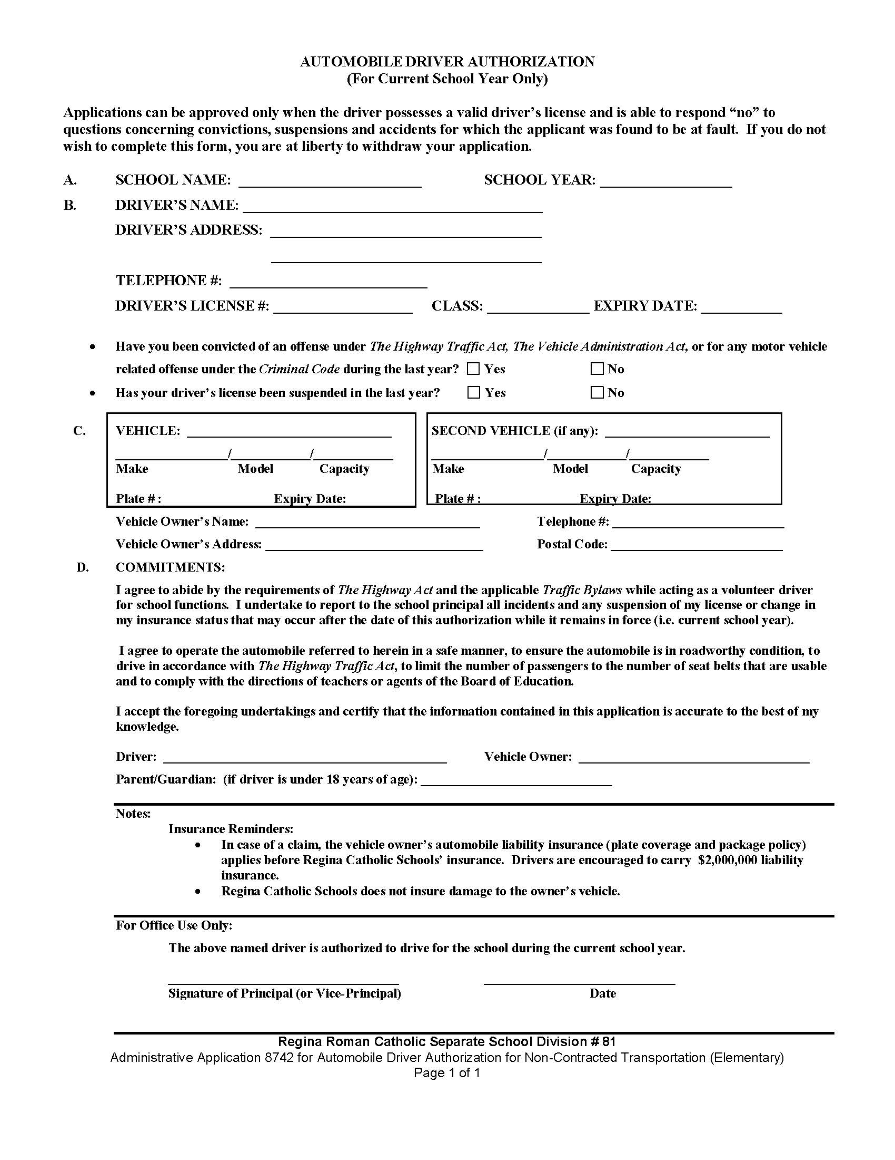

Regina Catholic Schools

Guidelines for Elementary Inter-School Sports Activities

Regina Catholic Schools enjoy a long-standing tradition of excellent elementary inter-school sports activities. The success of our sports program is built on the efforts and commitment of all the people involved – our students, staff, parents and volunteers. Our program is well organized and strengthened by a commitment to high expectations by volunteers, teachers and administrators.

The following guidelines have been prepared to serve as a reference for all students, staff, parents and volunteers to define responsibilities concerning the regulations and guiding principles for participation in the Regina Catholic Schools Elementary Inter-School Sports Program.

The Philosophy for Regina Catholic Schools Elementary Inter-School Sports

Elementary inter-school sports activities are an important part of the education program that contribute to students’ physical, mental, emotional and social development. These sports activities are organized to foster sportsmanship, fair play and respect for others before winning.

The Beliefs that Guide Our Actions
Inter-school sports activities in Regina Catholic Elementary Schools are guided by the following beliefs.
- We believe it is important to provide our students with opportunities for inter-school sports activities to encourage physical activity and skill development.

- We believe students who are engaged in inter-school sports activities develop better social skills and life skills.

- We believe inter-school sports activities provide opportunities for students to explore different sports and to enjoy positive interaction with others who have similar interests.

Actions and Indicators of Success
All staff and coaches are called to reflect our beliefs consistently in every aspect of the organization and operation of our elementary inter-school sports activities. Use the following indicators as measures of success.

- Our Catholic faith and values are expressed in our interactions with our students and community.
Indicators: Actions I can take to achieve this belief:
1.1 We pray together, especially before games.
1.2 We practice our Catholic faith.

1.3 We express our thanks and appreciation for the ability and opportunity to participate.
1.4 We express our positive appreciation and respect for others by speaking kindly.

- Every participant has the right to play in a safe and supportive learning environment.
Indicators: Actions I can take to achieve this belief:

2.1 Prior to the game, check the playing area and equipment to ensure safety.
2.2 Carry a First Aid Kit.
2.3 Ensure participants are dressed appropriately for the activity.
2.4 Be respectful of students.
2.5 Treat every student fairly as a valued person.
2.6 Ensure equal playing time for all students during the regular season.
2.7 Work to engage students who may be limited by socio-economic barriers.

- Coaching is directed at strengthening student skill development and an appreciation of sports.
Indicators: Actions I can take to achieve this belief:
3.1 Strive to be knowledgeable, positive and enthusiastic about the sport you are coaching.
3.2 Strive to be a model of active living and a healthy lifestyle.
3.3 Encourage students to develop a healthy, active lifestyle.
3.4 Plan and organize structured practices.
3.5 Encourage students to develop their athletic talents.

- Competitions, the application of rules and the conduct of athletes, coaches and officials contribute positively to fair play, good sportsmanship, positive relationships and experiences.
Indicators: Actions I can take to achieve this belief:
4.1 Coaches discuss and arrange games to ensure competition is fair and that each participating team has a reasonable chance to be successful.
4.2 Keep the score within a reasonable range.
4.3 Encourage energetic team spirit and supportive relationships.
4.4 Talk to negative fans and ask them to leave if necessary.
4.5 Team representatives should thank the officials for their efforts. Respect the officials’ decisions.
4.6 Recognize and celebrate participants’ efforts.
4.7 Encourage teammates to support one another.
4.8 Encourage all participants to shake hands as a sign of respect following the competition.

- Student character development is supported and strengthened through modelling positive behaviours.
Indicators: Actions I can take to achieve this belief:
5.1 Demonstrate how to maturely win and lose graciously.
5.2 Teach students how to be competitive within an ethical framework.

5.3 Acknowledge positive behaviours.
5.4 Explain, model and encourage the positive behaviours that are expected.
5.5 Take your boots off in the school and pick up any litter.

Guidelines for Communicating with Parents,
Student Code of Conduct and Participation Agreement Form

Understanding and support from parents is essential for the success of the Regina Catholic Schools Elementary Schools Sports Program.

Please use the following sample documents to support your school communications with parents and students.
- Letter to Parents

- Guidelines for Student Code of Conduct

- Participation Agreement Form: Students must return a signed copy of this form in order to participate. Coaches should keep the signed form on file until the end of the school year.

Sample letter to parents

Dear Parents:

Your son /daughter has expressed interest in participating in _________ (name of sport) at _________________ School.

Regina Catholic Schools believe that participation in inter-school sports is a significant part of the education program that enhances the quality of students’ lives and expands their options for learning and personal growth. Athletics provide an educational opportunity in which students can learn essential life lessons beyond those that can be learned in a classroom.

Participation on an athletic team demands a commitment that involves both dedication and sacrifice. Coaches and parents can help students develop positive character habits by discussing, modeling and reinforcing the desired attitudes and beliefs.

Inter-school sports activities in Regina Catholic Elementary Schools are guided by the following beliefs.
- We believe it is important to provide our students with opportunities for inter-school sports activities to encourage physical activity and skill development.

- We believe students who are engaged in inter-school sports activities develop better social skills and life skills.

- We believe inter-school sports activities provide opportunities for students to explore different sports and to enjoy positive interaction with others who have similar interests.
The structure of elementary inter-school athletics in Regina Catholic Schools is subject to season length, availability of volunteer staff and other limited resources. If team numbers are too high, it is difficult to provide adequate playing time, attention to individual skill development or to arrange transportation to and from games. For these reasons, we will conduct a selection process, using the criteria which have been developed in reference to the National Catholic Education Association’s document, Athletics and the Gospel Mission of the Catholic School by Rev. Richard McGrath, OSA, Ph. D. Father McGrath states:
“The very fact that Catholic schools offer athletic programs shows that athletic competition is valued as a way of teaching and training young men and women to cope with life in competitive circumstances. Competition in our society requires values that we all respect. Teamwork, honesty, cooperation, self-sacrifice, dedication, obedience, hard work, goal-setting, respect, self-discipline, and mutual encouragement are expected outcomes for young people who participate in sports. These traits are preparation for adult life. By offering athletic programs, Catholic schools are saying that they want to provide this avenue of expression for their students. Catholic schools cannot be satisfied just to have a program. The program should also excel; it should be competitive.”

Coaches will establish the eligibility criteria for participating on the team including:
- Attendance – students attend all practices and will notify the coach if they will be absent.
- Sportsmanship – students demonstrate a positive attitude and act as goodwill ambassadors for the school.
- “Coachability” – students are willing to respond to coaching instructions, suggestions, and ideas.
- Team Spirit – student behaviour towards all of their teammates is supportive at all times.
- Skill Level – a student’s skill level/ability is not a safety concern to self or others. Some consideration will be given to developing the skills of Grade 6 and 7 students, in order to create continuity and enhance the development of a strong, ongoing program for the school.

The Regina Catholic Elementary Schools Inter-School Sports Program is committed to providing students with a positive and enjoyable experience for all involved. Students must abide by the shared code of student conduct (listed below) to support team development and to uphold the values of Regina Catholic Schools.

All team members who maintain the aforementioned criteria will be given an opportunity to participate.

Parents are asked to:
- Be a positive role model through your actions to make sure your child has the best athletic experience possible.
- Be a “team” fan, not a “my kid” fan.
- Weigh what your children say; they may slant the truth to their advantage.
- Show respect for opposing players, coaches, spectators and support groups.
- Be respectful of all officials’ decisions.
- Don’t instruct your children before, during or after the game, because it may conflict with the coach’s plans and strategies.
- Praise student-athletes in their attempt to improve themselves as students, as athletes and as people.
- Gain an understanding and appreciation for the rules of the game.
- Recognize and show appreciation for an outstanding play by either team.
- Help your child learn that success is experienced in the development of their skills and they can feel good about themselves win or lose.

If you have any questions or concerns, please talk with the people involved. Take time to talk to the coach in an appropriate manner, including the proper time and place. Please follow the 24 hour rule: if you are upset – wait 24 hours to collect your thoughts, but don`t wait months or years – do communicate in a timely manner. If your question or concern is not appropriately addressed, please contact the school principal.

It will be the coach`s decision to enter into city championship play. Players will participate at the coach’s discretion. For playoffs, players will be placed in competitive situations that are appropriate to their level of readiness.

We look forward to working with you and hope that you support your child to take advantage of the tremendous opportunities that athletics provides.

(Insert closing from coach and school principal)

Guidelines for Students – Code of Conduct

A shared code of student conduct is established to support team development and to uphold the values of Regina Catholic Schools.

Students and their parents/guardians should understand that participation in Regina Catholic Elementary Inter-School Sports is regarded as a privilege and not a right. With this privilege comes the responsibility of making a commitment to the team, to a shared code of conduct and to do well in school in order to participate in a sport activity.

Students are asked to make the following pledge of commitment to their school and team to:
- Be Dependable: I will accept responsibility and demonstrate my commitment to fulfilling my obligations to my team.

- Be Punctual: I will be there for the team and be on time for practices and games.

- Respect for Self and Others: I will behave with dignity and treat others with respect and courtesy. My actions will not interfere with the rights of others - this includes my use of appropriate language, actions and attire. I will not harass others verbally or physically.

- Develop Skills: I will train and work to strengthen my level of physical conditioning and skills to participate competently in the game.

- Practice Good Manners: I will play by the rules and accept losing and winning gracefully, congratulate opponents, and not sulk or display other negative behaviours.

Any conduct that results in dishonor to the individual, team, or school will not be tolerated.

Regina Catholic Elementary Inter-School Sports
Participation Agreement Form

Students are required to return this signed form to be eligible to participate in the inter-school sports program. Your signature indicates that you wish your son /daughter to attend and participate in practices with the possibility of becoming involved with this school activity.

Please sign and return this form to the team coach to indicate that you have read the above letter and that you are willing to accept the outlined guidelines.

We have read and understand the guidelines for participation in elementary inter-school sports and agree to comply.

Date____________Parent Signature__________________________________________

Date____________Student Signature_________________________________________

